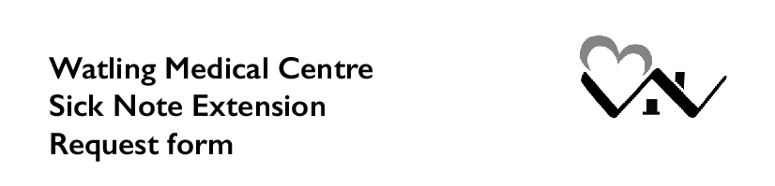

Please email this form to watling.secretary@nhs.net
All fields are mandatory.

Full Name:
Date of Birth:
Phone Number:
Email Address:
Today’s date:

First date you were not at work due to this illness:
Total number of days you were ill or state ongoing:
Date you would like the sick note to be extended to:

Describe the condition you need the sick note for.
In particular, please state if anything has changed in your condition since your last sick note:

